

Human Resource Management System.

**Supervisor:** Dr. Mohammad Taye.

**Submitted by**: Fahed Khalil - 201810264.

Wesam Da’abes – 201710036.

Malik Qawasmeh – 201710115.

**Approval**

We certify that we have read the project titled “Human Resourses Management System”, and as a members of project evaluation committee we had examined the students in the content of this document and knowledge related to it, and we certify that it is adequate with standings as a project for partial fulfillment of the requirements of B.Sc. in Software Engineering department.

Chairman Member

Name: Name:

Date: Date:

Signature: Signature:

**Certificate**

It is certified that this project has been prepared and written under my direct supervision and guidance. I also would like to certify that this document is approved for submission and evaluation.

Supervisor:

Signature:

Date:

**Table Of Contents:**

**Approval ................................................................................................................................. 2**

**Cirtificate ................................................................................................................................. 3**

**Table Of Contents ............................................................................................................... 4**

**List Of Figures ....................................................................................................................... 6**

**List Of Tables ......................................................................................................................... 7**

**Glossary Of Terms ............................................................................................................... 8**

**Chapter 1 – Project Proposal ......................................................................................... 9**

Title **........................................................................................................................................... 9**

Introduction **................................................................................................................................9**

Goals and Objectives **...............................................................................................................9**

Problem Statement **..................................................................................................................10**

Motivation **...............................................................................................................................10**

Literature Review **...................................................................................................................10**

Methodology **..........................................................................................................................10**

**Chapter 2 - Software Requirements Specification ............................................11**

1. Purpose **...........................................................................................................................11**
2. Scope **.............................................................................................................................. 11**
3. Overview **.......................................................................................................................** **11**

Overall Description **............................................................................................................ 12**

1. Product Prescriptive .........................................................................................12
2. Product Functions .............................................................................................13
3. User Characteristics ..........................................................................................13
4. Constraints .........................................................................................................13
5. Assumptions and dependencies ........................................................................13

**6.Apportioning of requirements............................................................................14**

7.Functional requirements ……………………………………………………...14

8.Non-Functional requirements ………………………………………………..16

9.Requerment Modeling ………………………………………………………..17

12.Requerement Validation…………………………………………………… 18

11. Hardware interfaces ……………………………………………………......18

12.Software interfaces ………………………………………………………….18

Chapter 3 - Software Architecture Design ………………………………..19

Introduction About Software Architecure ……………………………………...19

Benefits Of Software Architecture ……………………………………………..19

Importance Of Software Architecture ………………………………………….20

Selected technology ……………………………………………………………21

Chapter 4 - Detailed Design ………………………………………………… 23

Overview **……………………………………………………………………….23**

Class Diagram **………………………………………………………………….23**

Sequence Diagram **……………………………………………………………..25**

ER Diagram **……………………………………………………………………26**

Grafical User Interface **………………………………………………………...28**

**Chapter 5 – Implementation ……………………………………………….37**

Introduction About Implementaion **……………………………………………37**

Implementation Welcome Page code **………………………………………….37**

Implementation Login code **…………………………………………………...43**

Implementation Home code **…………………………………………………...44**

Implementation Add New Employee code **……………………………………48**

Implementation Requests Lists code **………………………………………….55**

Implementation Employee Management code **………………………………..57**

Implementation Apply Requests code **………………………………………..65**

Implementation My Requests code **…………………………………………..68**

Implementation Edit My Info code **…………………………………………..71**

**Chapter 6 – Testing …………………………………………………………77**

Overview **……………………………………………………………………..77**

Functional Testing **……………………………………………………………77**

Testing By Using **…………………………………………………………….82**

**Chapter 7 - Conclusion and future work ……………………………...83**

Conclusion **…………………………………………………………………...83**

Future Work **…………………………………………………………………83**

**References ……………………………………………………………………...84**

# Appendix ……………………………………………………………………… 85

# List Of Figures:

# Figure(1): Product perspective ………………………………………………... 12

# Figure(2):Calss diagram without operations ……………………………….... 17

# Figure(3): Use case ……………………………………………………………. .18

# Figure (4): Three Tier Architecture …………………………………………. .22

# Figure(5):class diagram ……………………………………………………….. 23

**Figure(6): Sequence diagram …………………………………………………. 25 Figure (7): ER diagram ……………………………………………………….. 26**

**Figure (8): Welcome page …………………………………………………….. 27**

**Figure(9): Login………………………………………………………………... 28**

**Figure(10): Home Page Admin………………………………………………... 29**

**Figure(11): Add New Employee………………………………………………. 30**

**Figure(12): Requests Admin………………………………………................... 31**

**Figure(13): Employee Management…………………………………………... 32**

**Figure(14): Home page User……………………………………………………33**

**Figure(15): Requests User………………………………………………………34**

**Figure(16): My Requests………………………………………………………..35**

**Figure(17): Edit My Info………………………………………………………. 36**

**Figures of Implementation code: …………………………………………….. 37**

**Figure(18):……………………………………………….37**

**Figure(19):……………………………………………….43**

**Figure(20):……………………………………………….44**

**Figure(21):……………………………………………….48**

**Figure(22):……………………………………………….55**

**Figure(23):……………………………………………….57**

**Figure(24):……………………………………………….61**

**Figure(18):……………………………………………….62**

**Figure(18):……………………………………………….66**

**Figure(18):……………………………………………….69**

**Figure(18):……………………………………………….72**

**Figures of Tesing: …………………………………………………………….. 78**

**Figure(29):……………………………………………….80**

**Figure(30):……………………………………………….80**

**Figure(31):……………………………………………….81**

**Figure(32):……………………………………………….81**

**Figure(33):……………………………………………….82**

**List Of Tables:**

**Table 1 : stakeholders ………………………………………………………… 9**

**Table 2 : Definitions, acronyms and abbreviations…………………………..9**

**Table 3 : Requirements Validation…………………………………………...18  
Table 4 : Black box testing…………………………………………………….76**

**Table 5 : Testing by using…………………………………………………….. 81**

**Table 1 : stakeholders**

|  |  |
| --- | --- |
| Actor | Interests |
| Managing Director | Salary, Job security,  Managing vacation request and adding or editing employees. |
| Employees | Salary, Job security, Vacation request or editing informations. |
| Company Owners | Business operations to run smoothly, Profit. |
| IT Developer | Create the website, Level of security, Privacy, Data Storage. |

**Table 2 : Definitions, acronyms and abbreviations**

|  |  |  |
| --- | --- | --- |
| **1** | SRS | Software Requirements Specification |
| **2** | EIN | Employee Identification Number |
| **3** | HRMS | Human Resource Management System |
| **4** | LMS | Leave Management System |
| **5** | Admin / Administrator | Administrator who is given specific permission for managing and  controlling the system |

**Chapter 1 – Project Proposal :**

**Title**

Human Resources Management System.

**Introduction**

The HR Management system is one of the most important systems that must be available in every company because it will save time and effort to complete some simple transactions. Job description is the completion of some transactions online, the most important of which is 1) Request a leave 2) Changing password 3) Showing the salary and its value for each employee per month 4) Each employee can register with the employee's identification number and password 5) Each employee can edit his personal info.

The proposed project "HR Management System" has been developed to overcome the problems faced in the practicing of manual system. This software is built to eliminate and in some cases reduce the hardships faced by the existing system. Moreover this system is designed for particular need of the company to carry out its operations in a smooth and effective manner.

It is a special system for employees in any company in which basic jobs are available for any employee, such as (vacations - leaves – edit info - monthly salary ).

**Goals and Objectives**

1) Useability and efficiency of employees services.

2) Generate reports of employee leaves or vacation and complaints.

3) To Add the employee salary.

**Problem Statement**

Overcoming the problems facing the manual system and creating transactions electronically to make it easier for employees and management to communicate between them .

**Motivation**

The motivation of the project is to provide employee services in a simple and fair way for business operations to run smoothly. Leave requests management also handle staffing requirements with ongoing policy and legal compliance.

**Literature Review**

Sagar informatics:

HR software to retain and develop employees, drive engagement, optimize benefits, and increase productivity.

sagar Informatics is HR software that features a record of assigned tasks, employee data analysis, employee monitoring, a centralized employee database, worksheet and timesheet management, and time-off tracking.

This software has a good track record of after-sales support and other customer service resources. Issues are dealt with promptly by email or phone and they have multiple numbers at which they can be reached.

Sap SuccessFactors:

Sap SuccessFactor is an engagement-focus HR tool that offers flexible employee surveys, role-based dashboards and reporting, customizable impact reports, event-based triggers, and employee rewards programs.

**Methodology:**

Waterfall model because requirement are very well known , product definition is stable

Technology is understood . easy to use , quality is more important than cost or schedule .

**Chapter 2 - Software Requirements Specification:**

**1.Purpose**

The purpose of this document is to give a detailed description of the requirements of HR Management System (HRMS). This document is primarily intended to be proposed to overcome the problems faced in the practicing of manual system, reduce the hardships faced by the existing system and to particular need of the company to carry out its operations in a smooth and effective manner.

**2.Scope**

HR Management System is a website used to complete some simple transactions using the Internet instead of the paper-based system. The site provides the following services1) Request a leave 2) Changing password 3) Showing the salary and its value for each employee per month 4) Each employee can register with the employee's identification number and password 5) Each employee can edit his personal info.

**3.Overview**

The remainder of this document includes three chapters and appendixes. The second one provides an overview of the system functionality and system interaction with other systems. This chapter also introduces different types of stakeholders and their interaction with the system. Further, the chapter also mentions the system constraints and assumptions about the product.

The third chapter provides the requirements specification in detailed terms and a description of the different system interfaces. Different specification techniques are used in order to specify the requirements more precisely for different audiences.

The fourth chapter deals with the prioritization of the requirements. It includes a motivation for the chosen prioritization methods and discusses why other alternatives were not chosen. The Appendixes in the end of the document include the all results of the requirement prioritization and a release plan based on them.

**OVERALL DESCRIPTION**

**1. Product perspective:**

This system consists of a website. The website will be used to facilitate the process of information exchange between the two parties of the manager and the employee and the completion of transactions for the employees.

The website will need to connect to the internet from any smart device in order to be able to use it. The website will provide the employee with jobs like (vacations - and salary inquiries)

The functions provided by the website will be included so that the user can use the functions in the application smoothly Since this is a data-driven product, it will need somewhere to store the data. Therefore, a database will be used. The website will communicate with the database.

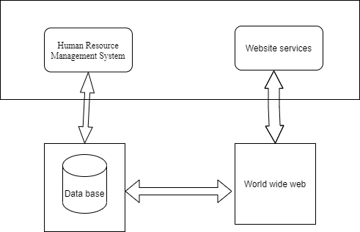

**Figure(1): Product perspective**

**2.Product Functions**

Completing some online transactions, the most important of which are (requesting leave, submitting a complaint, or Add the employee's salary.

**3.User Characteristics**

There are three types of users that interact with HRMS: Employees, Managing Director/Admin and Company Owners . Each of these three types of users has different use of the system so each of them has their own requirements.

Employees: The website provides the following services for employees: 1) Request leave or submit a complaint/report to the manager 2) The daily work schedule in addition to the number of additional hours desired by the employee 3) Inquire about the salary and its value with OP working this month 4) Each employee can register with the EIN and password.

Managing Director/Admin: Manager is also an employee and his interests in the website will be: Salary, Working hours, Job security. But he has a special validity which is managing vacation request and reports. Which is mean he can accept or reject the vacation request or reports.

Company Owners: The only thing that company owners are interested in the website is profit and business operations to run smoothly.

**4.Constraints**

Internet connection is also restricted on the website. Since the website fetches data from the database over the internet, it is vital that there is an internet connection for the website to function.

**5.Assumptions and dependencies**

One of the assumptions about the product is that it will always be used on the website accessed from any smart device. For example, users may have customized it with other websites, there may be scenarios where the website does not function as intended or even at all.

**6.Apportioning of requirements**

In the case that the project is delayed, there are some requirements that could be transferred to the next version of the website.

**7. Functional requirements:**

This section includes the requirements that specify all the main actions of the software system.

**Functional Requirement 1**

**TITLE:** log in

**DESC:** The user must be able to enter the site and choose the employee or manager **RAT**: for the user to use the website

**DEP:** FR1.

**Functional Requirement 2**

**TITLE**:  change Password

**DESC**: The password change or restore

**RAT**: To maintain privacy

**DEP**: None

**ID**: FR3

**TITLE**:  Add new employee

**DESC**: The Admin can add a new employee for the employee to use the website

**RAT**: for the user to use the website

**DEP**: None

**ID**: FR4

**TITLE**: Request holiday or leave

**DESC**: Employees are allowed to request holiday or leave

**RAT**: In order for the employee to complete the transaction

**DEP**: None

**ID**: FR5

**TITLE**: view the salary

**DESC**: Employees are allowed to view the salary amount

**RAT**: So that the employee can get the salary

**DEP**: None

**ID**: FR6

**TITLE**:  Accept or reject  holidays or leave

**DESC**: The Admin can approve or deny a holidays or leave To the employee with the reason written

**RAT**: So that employees can get it

**DEP**: None

**ID**: FR7

**TITLE**:  View the salary

**DESC**: The Admin can View the salary To the employee

**RAT**: So that employees can get it

**DEP**: None

**ID**: FR8

**TITLE:** Request a service

**DESC:** The employee must be able to request a service he wants to provide to him by sharing and waiting for a response from the manager.

**RAT**: for the user to request a required service.

**ID:** FR9

**TITLE** **:**Website - Profile Page

**DESC:** On the website, the user must have a profile page. On the profile page, the user can edit their information, which includes password, email address and phone number. The user must also be able to choose which language to understand. The different language options are Arabic and English.

**RAT:** in order for a user to have a profile page on the website.

**8. Non-Functional Requirements:**

**ID: QR1**

**TITLE:** Usability

**DESC**: website should be easy to learn, support speed performance, low error rate and user attitude.

**RAT:** In order for a user to use the system easily

**DEP:** None

**Requerment Modeling**

**Class diagram:**

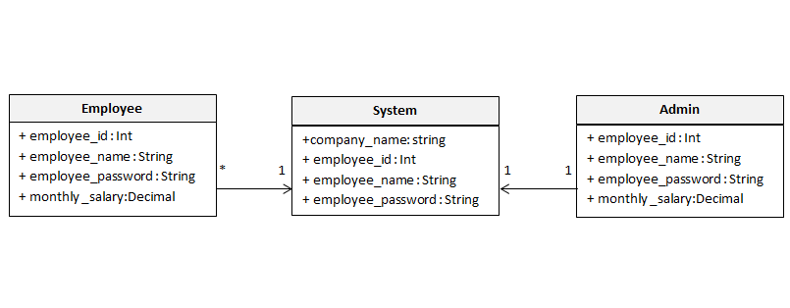

**Figure(2):Calss diagram without operations**

**In Figure(2):**

**Employee class:** has the employee name,emp id ,emp password and monthly salary attributes

**Admin or Manager class:** has the employee name,emp id ,emp password and monthly salary attributes.

**System class:** The attributes are the company name, employee name, emp id and emp password.

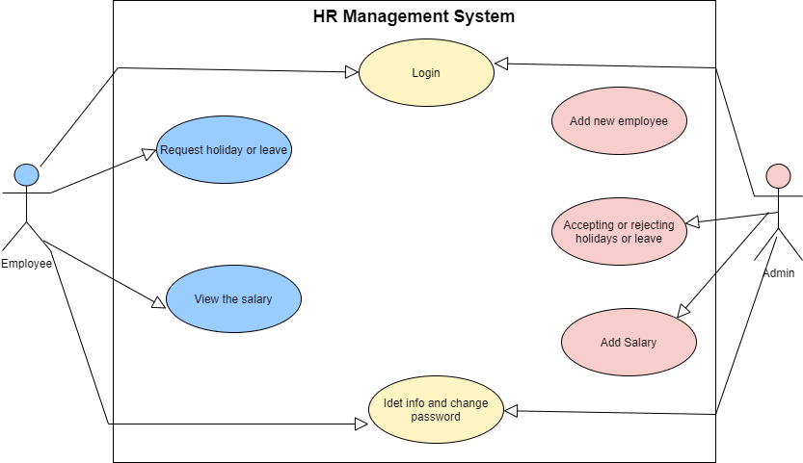**Use Case:**

**Figure(3): Use case**

**Requirements Validation**

**Table 3 : Requirements Validation**

|  |  |  |  |
| --- | --- | --- | --- |
|  | **Question** | **Yes** | **No** |
| **1** | Does it possible to implement all of the requirements? | Yes |  |
| **2** | Is the maintainability of the system/software specified?  Including the ability to respond to changes in the operating environment, interfaces, accuracy, performance, and additional predicted capabilities. |  | No |
| **3** | Have requirements for communication among system/software components been specified? | Yes |  |
| **4** | Have overall function and behavior of the system/software been defined? | Yes |  |
| **5** | Is the maximum memory specified? |  | No |
| **6** | Do the requirements define all the information that is to be displayed to the user? | Yes |  |
| **7** | Are there conflicting requirement? |  | No |
| **8** | Is each requirement testable? | Yes |  |
| **9** | Is the level of security specified? | Yes |  |
| **10** | Have the software and hardware environments been defined? | Yes |  |
| **11** | Are the specified error messages unique and meaningful? | Yes |  |
| **12** | Is each requirement in scope for the project? | Yes |  |

**10.Hardware interfaces**

The system does not have any hardware interfaces since it will take the form of a website deployed on a server.

**11.Software interfaces**

HR Management System is a website used to complete some simple transactions using the Internet instead of the paper-based system.

# Chapter 3 - Software Architecture Design:

# Introduction About Software Architecure

The software architecture of a system depicts the system’s organization or structure, and provides an explanation of how it behaves. A system represents the collection of components that accomplish a specific function or set of functions. In other words, the SE Architecture provides a sturdy foundation on which software can be built.

A series of architecture decisions and trade-offs impact quality, performance, maintainability, and overall success of the system. Failing to consider common problems and long-term consequences can put your system at risk.

There are multiple high-level architecture patterns and principles commonly used in modern systems. These are often referred to as architectural styles. The architecture of a software system is rarely limited to a single architectural style. Instead, a combination of styles often make up the complete system.

# Benefits Of Software Architecture

1. **Higher productivity:** It is easier to add new features to existing software, since the structure is already in place, and the location for every new piece of code is known beforehand.
2. **Better code maintainability:** It is easier to maintain software based on an architecture, as the structure of the code is visible and known, so it’s easier to extend the software or find bugs and anomalies.
3. **Higher adaptability:** New features, such as a different front end, or adding a process rule are easier to achieve, as the software architecture creates a clear separation of concerns.
4. **Quality:** More reliable assessment of system quality attributes like performance, security, interoperability, reliability, availability.

# Importance Of Software Architecture

**Meeting the Requirements:**

A software architecture comprises information from various stakeholders such as domain experts, business analysts, product owners, and end-users. This information helps you identify and meet different functional, non-functional, technical, and operational requirements. A [successful requirements management](https://www.kovair.com/blog/successful-requirements-management-eliminates-project-defects/) can help you eliminate many project defects.

**Ensuring Quality:**

Software architecture can be designed to focus on specific quality attributes of a system such as performance, features, security, and interoperability. Generally, these quality attributes do not always stay in accordance with one another.

A software architecture establishes an agreed-upon and validated quality requirements and standards for the products. It also lets you predict a software system’s qualities and avoid costly rework.

**Facilitating Communication among Stakeholders:**

Software architecture and its documentation are simple and comprehensive enough that any stakeholders can reason about the software system. It lets you communicate and explain the software system to others. It can be a basis for discussions and negotiations regarding various aspects of a project such as cost, quality and duration.

**Embracing Change:**

There can be many changes in a software system such as new requirements, market changes, changes to business processes, bug fixes,  technology advances, and many more; especially in the modern [agile development process](https://www.kovair.com/blog/how-enterprises-can-successfully-scale-agile-development-process/) change is the only constant.  Good software architecture can help the team anticipate and adapt to these changes without necessarily having to make architectural changes.

**Providing a Reusable Model:**

The code and early decisions that shaped the architecture are reusable for projects that have similar requirements and structures. Not only does this save us a lot of time and effort, but this tested and proven architecture also ensures and increases the quality of products.

**Estimating Cost and Effort:**

The design of the software architecture itself affects the kind of tasks necessary for the implementation. In this way, the project managers can break down the work as individual tasks based on the nature and size of the project.

The project managers break down final deliverables and goals into smaller packages of work. And the developers initially start with specific tasks and then group them into packages of work. By reducing these complexities, we can achieve more accurate cost and effort estimates.

**Selected technology**

**What is your software Architecture?**

It’s a three tier Architecture.

**Why did you choose it?**

• Three-tier architecture is a well-established software application architecture that organizes applications into three logical and physical computing tiers: the presentation tier, or user interface; the application tier, where data is processed; and the data tier, where the data associated with the application is stored and managed.

• The chief benefit of three-tier architecture is that because each tier runs on its own.

**The three tiers in details**

Three-tier application architecture is a modular client-server architecture that consists of a presentation tier, an application tier and a data tier. The data tier stores information, the application tier handles logic and the presentation tier is a graphical user interface (gui) that communicates with the other two tiers. The three tiers are logical, not physical, and may or may not run on the same physical server.

**Presentation tier**

The presentation tier is the user interface and communication layer of the application, where the end user interacts with the application. Its main purpose is to display information to and collect information from the user. This top-level tier can run on a web browser, as desktop application, or a graphical user interface (GUI), for example. Web presentation tiers are usually developed using HTML, CSS and JavaScript. Desktop applications can be written in a variety of languages depending on the platform.

**Application tier**

The application tier, also known as the logic tier or middle tier, is the heart of the application. In this tier, information collected in the presentation tier is processed - sometimes against other information in the data tier - using business logic, a specific set of business rules. The application tier can also add, delete or modify data in the data tier.

The application tier is typically developed using Python, Java, Perl, PHP or Ruby, and communicates with the data tier using [API](https://www.ibm.com/cloud/learn/api) calls.

**Data tier**

The data tier, sometimes called database tier, data access tier or back-end, is where the information processed by the application is stored and managed. This can be a [relational database management system](https://www.ibm.com/cloud/learn/relational-databases) such as [PostgreSQL](https://www.ibm.com/cloud/learn/postgresql), MySQL, MariaDB, Oracle, DB2, Informix or Microsoft SQL Server, or in a [NoSQL](https://www.ibm.com/cloud/learn/nosql-databases) Database server such as Cassandra, [CouchDB](https://www.ibm.com/cloud/learn/couchdb) or [MongoDB](https://www.ibm.com/cloud/learn/mongodb).

In a three-tier application, all communication goes through the application tier. The presentation tier and the data tier cannot communicate directly with one another.

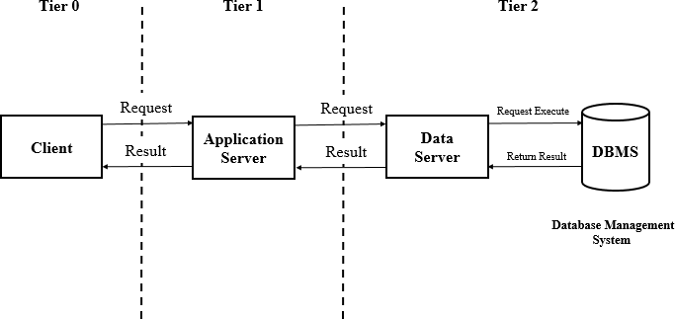

**Figure (4): Three Tier Architecture**

**Chapter 4 - Detailed Design**

**Overview**

In this chapter, a design of the HR Management System will be introduced. Starting with the class diagram where the structured view of the system will be set. After that sequence diagram that shows the sequence of messages passed between objects. also show the control structures between objects. Then the database modeling will be discussed.The Entity Relationship diagram to show all entities of the system and the data to be stored about them. Finally the Graphical User Interface designs will be specified.

**Class diagram**

Here will see the class diagram for the HRMS in Figure (4). That illustrate a system’s structure in a detailed way ,showing its attributes ,operations as well as its relations.

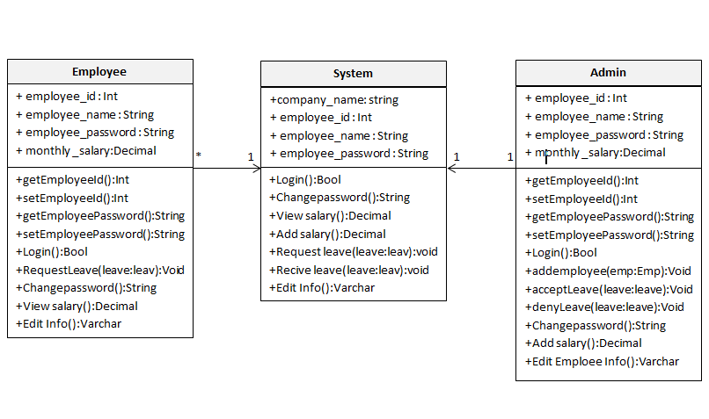

**Figure(5):class diagram**

**In Figure(5):**

**Employee class**: has the employee name,emp id ,emp password and monthly salary attributes.

And there are many operations such as: 1) Request a leave 2) Changing password 3) Showing the salary and its value for each employee per month 4) Each employee can register with the employee's identification number and password 5) Each employee can edit his personal info.

**Admin or Manager class**: has the employee name,emp id ,emp password and monthly salary attributes. And there are many operations such as: 1) Recive a leave 2) Accepting or dinying leaves or holiday forms from employees 3) Adding salary for each employee per month 4) The manager can register with the identification number and password 5) Add Employees 6) Edit the employees info.

**System class**: The attributes are the company name, employee name, emp id and emp password.

And has many operation such as: login, changing password, view/add the salary , request/recive leaves and edit employee info.

The relation between employee class and system class are association(* to 1) that means many employees used one system.And the relation between admin class and system class are association(1 to 1) that means one admin used or can use one system.

**Sequence diagram**

A sequence diagram or system sequence diagram shows object interactions arranged in time sequence in the field of software engineering. It depicts the objects involved in the scenario and the sequence of messages exchanged between the objects needed to carry out the functionality of scenario.

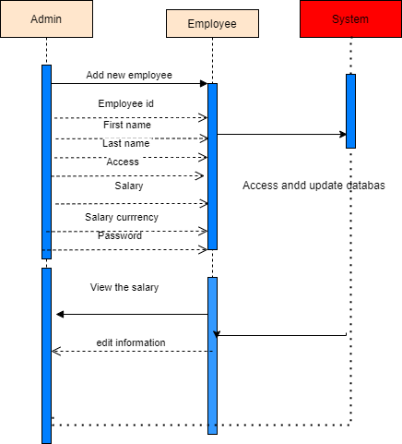

**Figure(6):** Sequence diagram

**In Figure(6):**

In this figure, it shows the process of Sequence diagram to add a new employee by entering the employee's number, name and salary and making a password for him and then store it in the database.

**ER diagram:**

The ER diagrams describe the entities of the system and shows their attributes and the relations among them.  
 The ER diagram of our system is below:

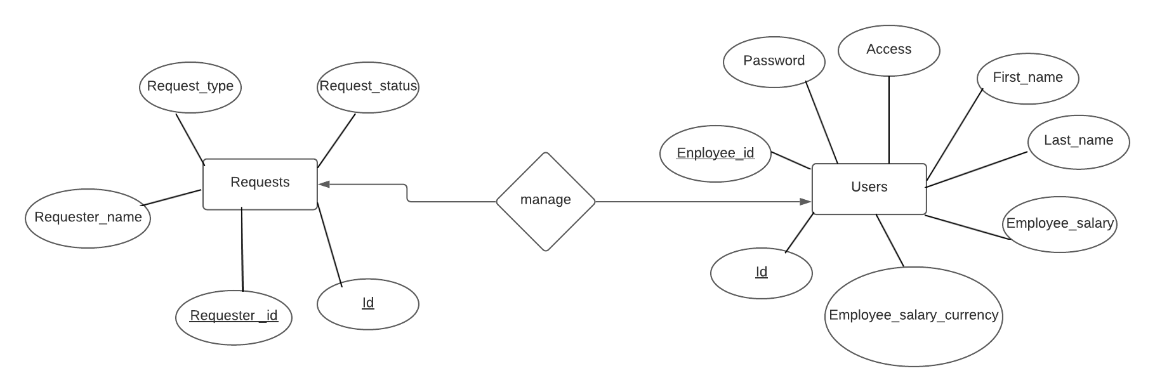

**Figure (7): ER diagram**

**Human Resource Management System entities and their attributes:**

• **Users Entity:** Attributes of Users are: id, employee_id, First_name, Last_name, Access , Employee_salary , Employee_salary_currency .

• **Requests Entity:** Attributes of Requests are: id, Requester_id, Requester_name, Request_type, Request_status.

**Graphical User Interfaces**



**Figure (8): Welcome page  
The welcome page of the project its the first page in the website and it contains about us and contact us and the button of login.**

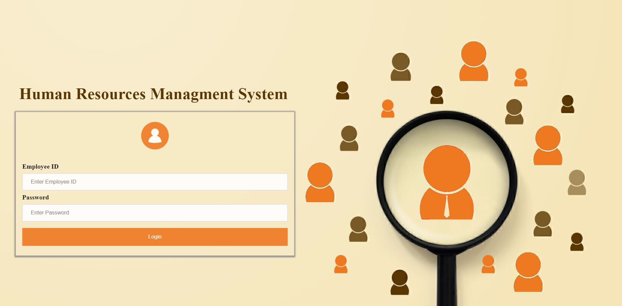

**User interfaces design:**

**Figure(9): Login**

On this page, the admin or the user can enter the site using the employee's number and password

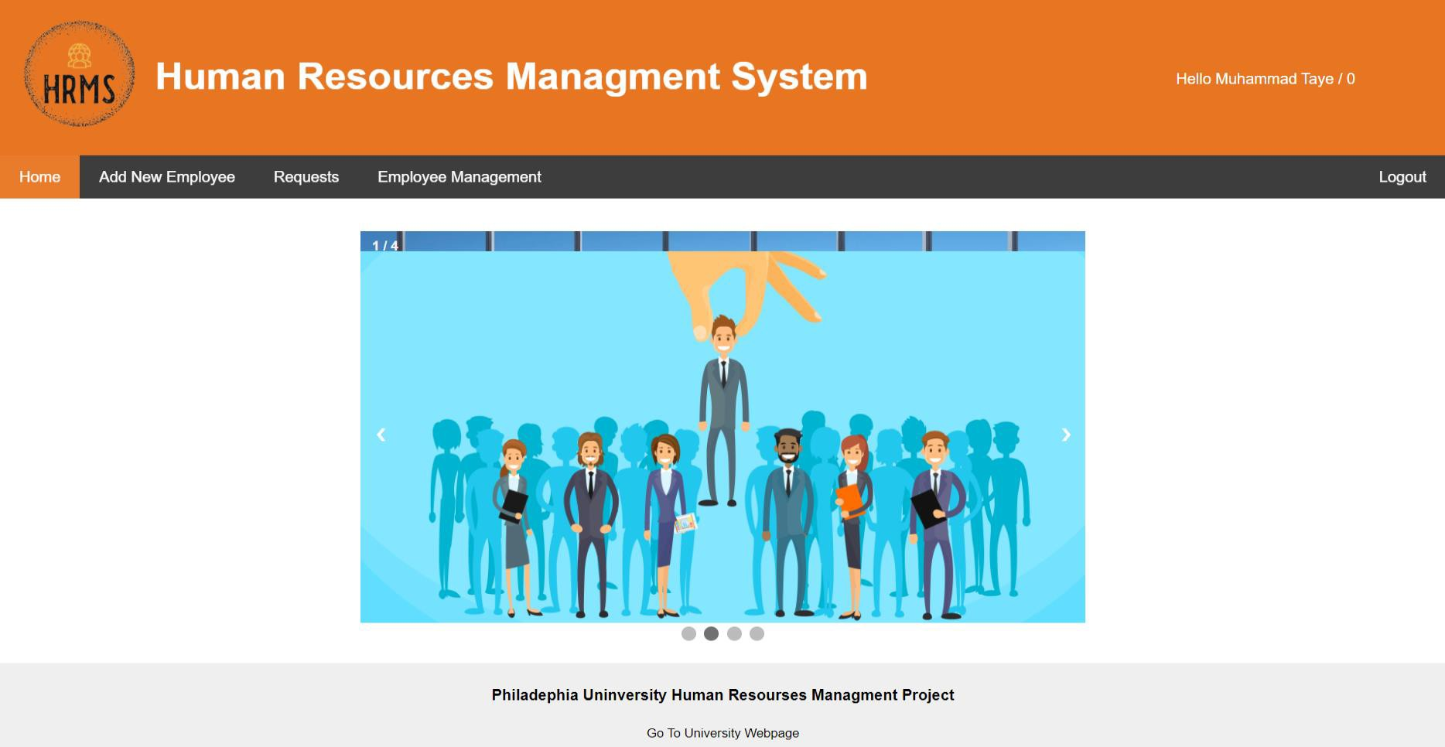

**Figure(10): Home Page Admin**

Home Page is the first and welcome page for the user

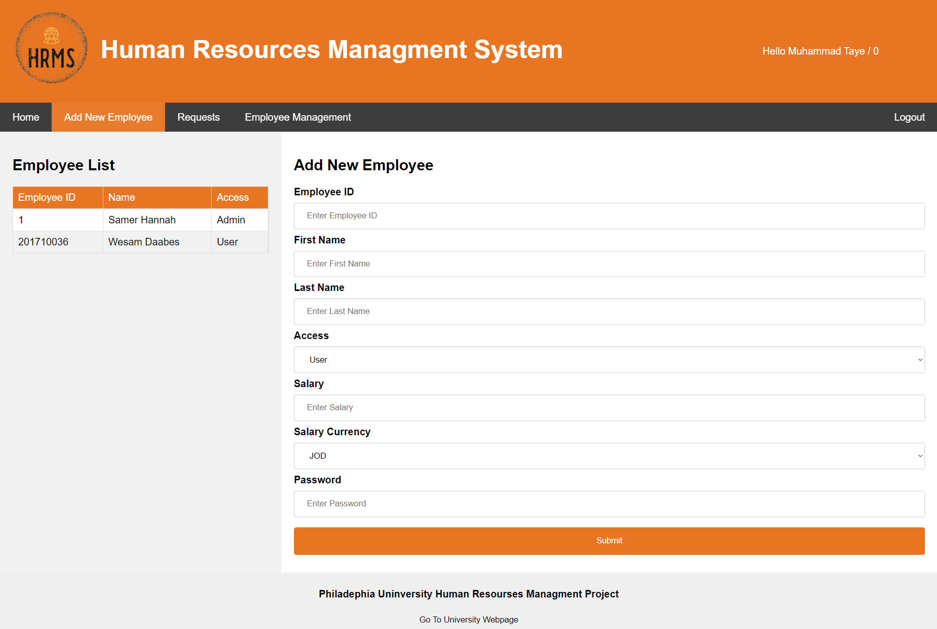

**Figure(11): Add New Employee**

On this page, the admin can add a new employee and determine his salary

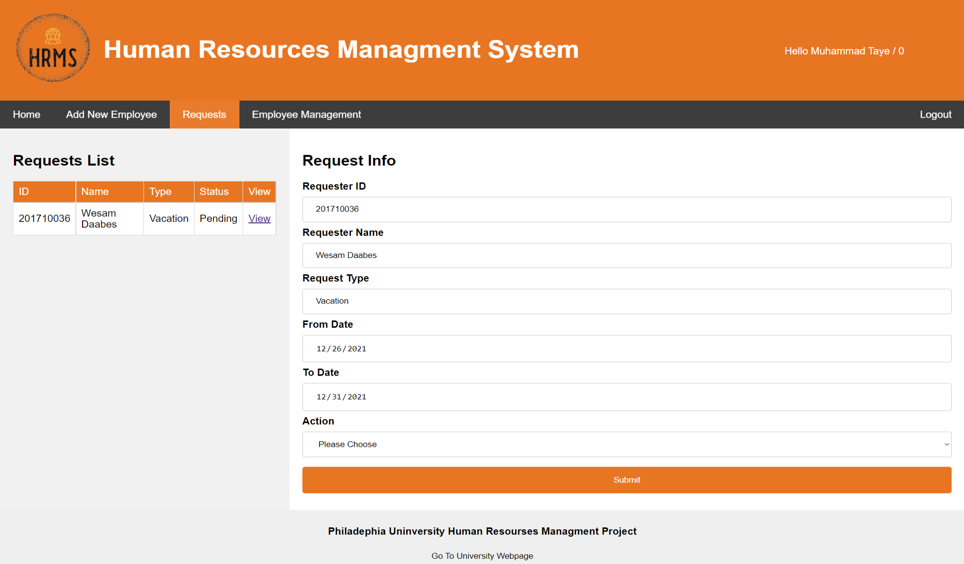

**Figure(12): Requests Admin**

On this page, the admin responds to the vacations or departures provided by the employees by rejecting or accepting

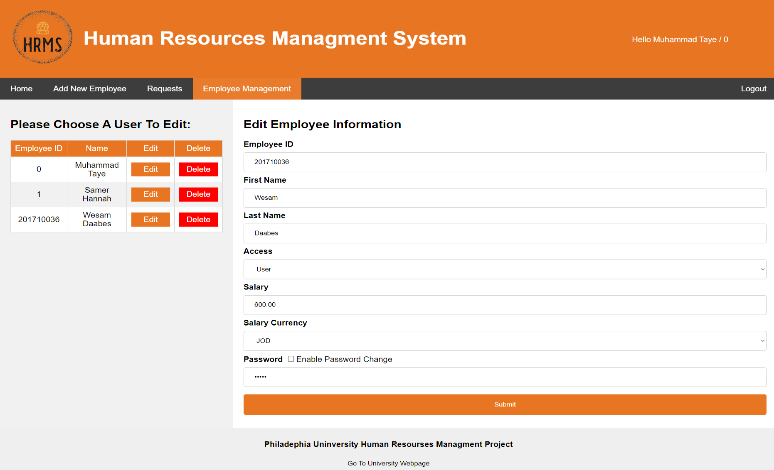

**Figure(13): Employee Management**

On this page, the admin edits employee information or deletes an employee

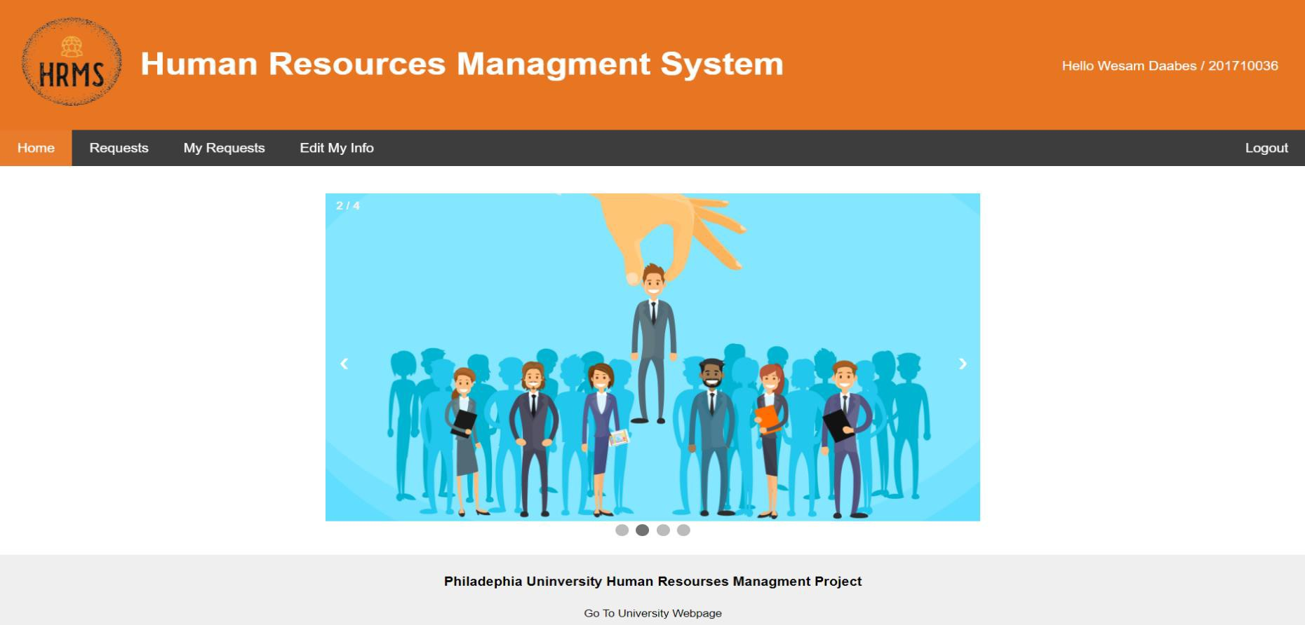

**Figure(14): Home page User**

Home Page is the first and welcome page for the user

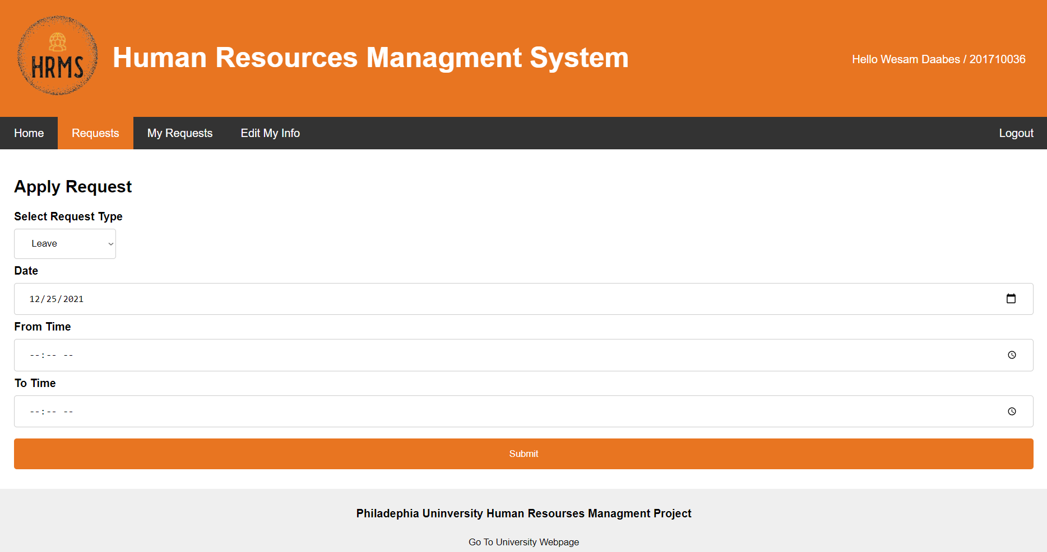

**Figure(15): Requests User**

On this page, the employee submits a leave or leave that he desires,specifying the date and time

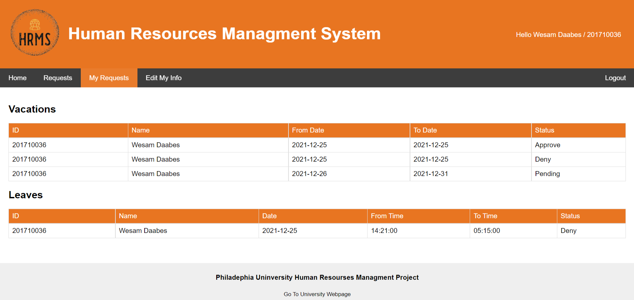

**Figure(16): My Requests**

Here, the employee shows the leaves or departures that he previously submitted and shows that they were accepted or rejected by the admin.

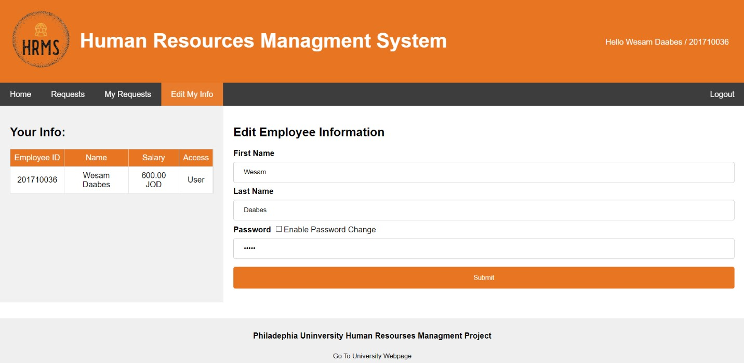

**Figure(17): Edit My Info**

On this page, the employee can modify his name and password

**Chapter 5 - Implementation**

**Code:**

Process of adopting and integrating a software application into a business workflow , Prior to implementation, the software should be selected by assessing needs, budget, potential benefits, obstacles, and so forth. Once the solution is chosen, implementation can begin.

The following is the code of important figures in the system.



**Figure(18): Welcome Page**

<style>

body{

margin: 0;

padding: 0;

font-family: "montserrat",sans-serif;

}

.first-page{

width: 100;

height: 100vh;

position: relative;

overflow: hidden;

}

.first-page::after{

content: "";

position: absolute;

left: 0;

top: 0;

width: 100%;

height: 100%;

background-image: url(images/logo.png);

background-size: cover;

animation: anim 25s linear infinite;

}

@keyframes anim {

50%{

transform: scale(2);

}

100%{

transform: scale(1);

}

}

.page-content{

position: absolute;

top: 50%;

left: 50%;

transform: translate(-50%,-50%);

z-index: 1;

width: 100%;

max-width: 800px;

text-align: center;

padding: 0 40px;

box-sizing: border-box;

}

.page-content h1{

color: #EF7821;

text-transform: uppercase;

font-size: 50px;

font-weight: 900;

margin-bottom: 20px;

}

.page-content p{

color: #fff;

margin-bottom: 20px;

}

.page-content a{

display: inline-block;

text-decoration: none;

color: #EF7821;

border: 2px solid #EF7821;

text-transform: uppercase;

padding: 10px 20px;

transition: 0.4s linear;

}

.page-content a:hover{

color: #fff;

background: #EF7821;

}

.text{

padding: 10px;

text-align: justify;

}

.text div{

margin-bottom: 6px;

}

.about{

border: 2px solid #EF7821;

}

.contact{

border: 2px solid #EF7821;

}

.about:hover{

background-color: #EF7821;

}

.contact:hover{

background-color: #EF7821;

}

.footer {

padding: 5px;

text-align: center;

background: #ddd;

background-color: #efefef;

flex: 0 0 50px;

margin-top: auto;

opacity: .5;

}

.WebpageButton {

background-color: transparent;

background-repeat: no-repeat;

border: none;

cursor: pointer;

overflow: hidden;

outline: none;

}

</style>

</head>

<body>

<div class="first-page">

<div class="page-content">

<h1>Human Resources Management System</h1>

<p></p>

<a href="index.html">Get Started</a>

</div>

</div>

<div class="container-fluid">

<div class="row">

<div class="about col-lg-6" data-aos="fade-right" data-aos-offset="200" data-aos-duration="1000" data-aos-delay="50">

<h3>About Us :</h3>

<p>The HR Management system is one of the most important systems that must be available in every company because it will save time and effort to complete some simple transactions. Job description is the completion of some transactions online, the most important of which is 1) Request a leave 2) Changing password 3) Showing the salary and its value for each employee per month 4) Each employee can register with the employee's identification number and password 5) Each employee can edit his personal info.</p>

</div>

<div class="space col-lg-1">

</div>

<div class="contact col-lg-5" data-aos="fade-left" data-aos-offset="200" data-aos-duration="1000" data-aos-delay="50">

<h3>Contact Us :</h3>

<h5>Human resourses Management Project</h5>

<p>Fahed,Wesam,Malik</p>

<p>Mobile Number : +962786703615</p>

<p>Email:HRMS@Gmail.com</p>

</div>

</div>

</div>

<div class="footer">

<h4>Philadephia Uninversity Human Resourses Managment Project</h4>

<input class="WebpageButton" type="button" onclick="location.href='https://www.philadelphia.edu.jo';" value="Go To University Webpage" />

</div>

**Admin Portal :**

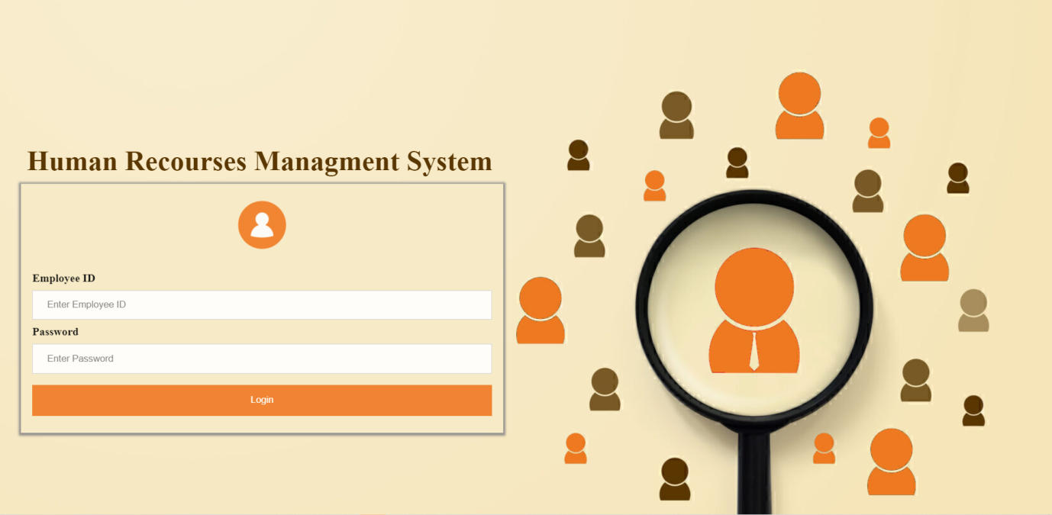  
  
 **Figure (19) Login**  
  
<?php

session_start();

if (isset($_POST['Employee_ID']) && $_POST['Password'] != "") {

$Employee_ID=$_POST["Employee_ID"];

$Password=$_POST["Password"];

require 'conn.php';

$sql="SELECT * FROM users WHERE Employee_ID ='$Employee_ID' and Password='$Password'";

$stmt = $conn->query($sql);

while($row = $stmt->fetch_assoc()) {

$_SESSION['Employee_ID'] = $row['Employee_ID'];

$_SESSION['First_Name'] = $row['First_Name'];

$_SESSION['Last_Name'] = $row['Last_Name'];

$_SESSION['Access']= $row['Access'];

$_SESSION['Status']='Active';

header('location:../Homepage.php');

}

echo 'Wrong Username or Password !';

}

?>

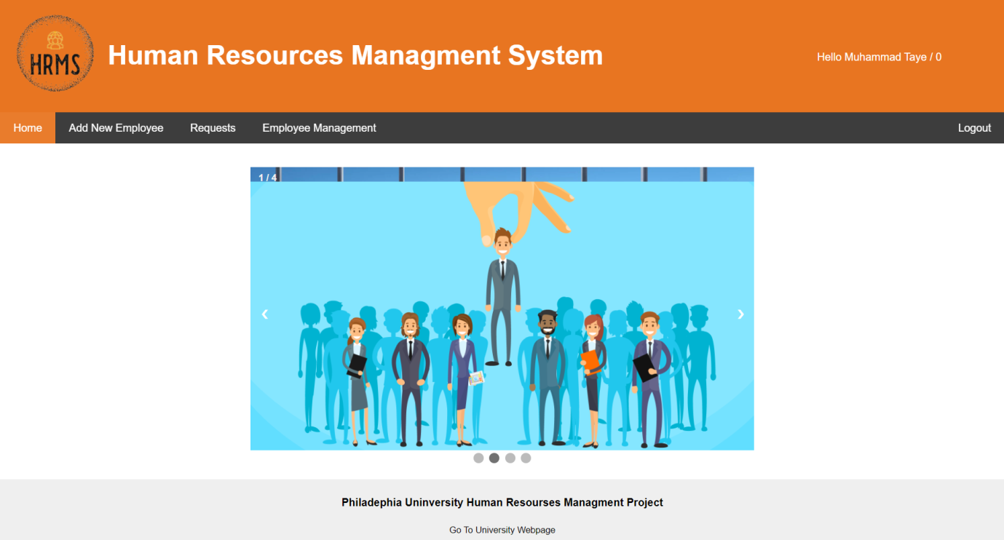  
  
 **Figure (20) Home page**

<?php

session_start();

if($_SESSION['Status']!="Active")

{

header('location:index.html');

exit;

}

?>

<!DOCTYPE html>

<html lang="en">

<head>

<title>HomePage</title>

<meta charset="UTF-8">

<meta name="viewport" content="width=device-width, initial-scale=1">

<style>

* {

<?php

if ($_SESSION['Access']=="Admin") {

echo '<a href="AddEmployee.php">Add New Employee</a>';

}

?>

<a href="Requests.php">Requests</a>

<?php

if ($_SESSION['Access']!="Admin") {

echo '<a href="MyRequests.php">My Requests</a>';

}

if ($_SESSION['Access']=="Admin") {

echo '<a href="Employee_Managment.php">Employee Management</a>';

}

if ($_SESSION['Access']!="Admin") {

echo '<a href="Employee_Managment.php">Edit My Info</a>';

}

?>

<a href="php/logout.php" class="right">Logout</a>

</div>

var slideIndex = 1;

showSlides(slideIndex);

function plusSlides(n) {

showSlides(slideIndex += n);

}

function currentSlide(n) {

showSlides(slideIndex = n);

}

function showSlides(n) {

var i;

var slides = document.getElementsByClassName("mySlides");

var dots = document.getElementsByClassName("dot");

if (n > slides.length) {slideIndex = 1}

if (n < 1) {slideIndex = slides.length}

for (i = 0; i < slides.length; i++) {

slides[i].style.display = "none";

}

for (i = 0; i < dots.length; i++) {

dots[i].className = dots[i].className.replace(" active", "");

}

slides[slideIndex-1].style.display = "block";

dots[slideIndex-1].className += " active";

}

</script>

<script>

let sliderimage=2;

setInterval(function() {

currentSlide(sliderimage);

sliderimage=sliderimage+1;

if(sliderimage>4){sliderimage=1;}

}, 2500);

</script>

<div class="footer">

<h4>Philadephia Uninversity Human Resourses Managment Project</h4>

<input class="WebpageButton" type="button" onclick="location.href='https://www.philadelphia.edu.jo';" value="Go To University Webpage" />

</div>

</body>

</html>

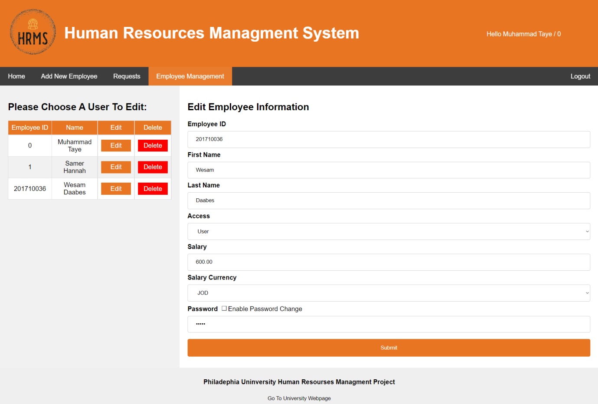

**Figure (21) Employee management**   
  
<?php

session_start();

if($_SESSION['Status']!="Active")

{

header('location:index.html');

exit;

}

?>

<!DOCTYPE html>

<html lang="en">

<head>

<title>Add New Employee</title>

<meta charset="UTF-8">

<meta name="viewport" content="width=device-width, initial-scale=1">

<style>

* {

<?php

if ($_SESSION['Access']=="Admin") {

echo '<a href="AddEmployee.php">Add New Employee</a>';

}

?>

<a href="Requests.php">Requests</a>

<?php

if ($_SESSION['Access']!="Admin") {

echo '<a href="MyRequests.php">My Requests</a>';

}

if ($_SESSION['Access']=="Admin") {

echo '<a style="background-color:#E87521;" href="Employee_Managment.php">Employee Management</a>';

}

if ($_SESSION['Access']!="Admin") {

echo '<a style="background-color:#E87521;" href="Employee_Managment.php">Edit My Info</a>';

}

?>

<a href="php/logout.php" class="right">Logout</a>

</div>

<?php

if($_SESSION['Access']=="Admin")

{

?>

<div class="side">

<h2>Please Choose A User To Edit:</h2>

<style>

function LoadUser(UserRowID)

{

if (window.XMLHttpRequest)

{

xmlhttp=new XMLHttpRequest();

}

xmlhttp.onreadystatechange=function()

{

if (xmlhttp.readyState==4 && xmlhttp.status==200)

{

document.getElementById("Load_User_DIV").innerHTML=xmlhttp.responseText;

}

}

xmlhttp.open("GET","php/Load_User_To_DIV.php?UserRowID="+UserRowID,true);

xmlhttp.send();

}

</script>

<?php

require 'php/conn.php';

$Employee_ID=$_SESSION['Employee_ID'];

$sql="SELECT * FROM users Order BY Employee_ID ASC";

$stmt = $conn->query($sql);

echo"<table>";

echo"<tr class='firstrow'><td>Employee ID</td><td>Name</td><td>Edit</td><td>Delete</td></tr>";

while($row = $stmt->fetch_assoc()) {

$Employee_ID= $row['Employee_ID'];

$First_Name = $row['First_Name'];

$Last_Name = $row['Last_Name'];

$Access= $row['Access'];

$ROW_ID= $row['ID'];

echo"<tr><td>".$Employee_ID."</td><td>".$First_Name." ".$Last_Name."</td><td style='text-align:center;'><button class='EditBTN' onclick='LoadUser(".$ROW_ID.");'>Edit</button></td><td style='text-align:center;'><button class='DeleteBTN' onclick='window.location=\"php/DeleteUser.php?ROW_ID=".$ROW_ID."\"'>Delete</button></td></tr>";

}

echo"</table>";

?>

</div>

<?php } else {?>

<div class="side">

<h2>Your Info:</h2>

<style>

function LoadUser(UserRowID)

{

if (window.XMLHttpRequest)

{

xmlhttp=new XMLHttpRequest();

}

xmlhttp.onreadystatechange=function()

{

if (xmlhttp.readyState==4 && xmlhttp.status==200)

{

document.getElementById("Load_User_DIV").innerHTML=xmlhttp.responseText;

}

}

xmlhttp.open("GET","php/Load_User_To_DIV.php?UserRowID="+UserRowID,true);

xmlhttp.send();

}

</script>

<?php

require 'php/conn.php';

$Employee_ID=$_SESSION['Employee_ID'];

$sql="SELECT * FROM users WHERE Employee_ID='$Employee_ID' Order BY Employee_ID ASC";

$stmt = $conn->query($sql);

echo"<table>";

echo"<tr class='firstrow'><td>Employee ID</td><td>Name</td><td>Salary</td><td>Access</td></tr>";

while($row = $stmt->fetch_assoc()) {

$Employee_ID= $row['Employee_ID'];

$First_Name = $row['First_Name'];

$Last_Name = $row['Last_Name'];

$Access= $row['Access'];

$ROW_ID= $row['ID'];

$Employee_Salary= $row['Employee_Salary'];

$Employee_Salary_Currency= $row['Employee_Salary_Currency'];

echo"<tr><td>".$Employee_ID."</td><td>".$First_Name." ".$Last_Name."</td><td>".$Employee_Salary." ".$Employee_Salary_Currency."</td><td>".$Access."</td></tr>";

}

function PWD(CHK)

{

if(CHK=="Disabled")

{

document.getElementById('PWD_CHK').value="Enabled";

document.getElementById('Password').readOnly=false;

}

if(CHK=="Enabled")

{

document.getElementById('PWD_CHK').value="Disabled";

document.getElementById('Password').readOnly=true;

}

}

</script>

</div>

<div class="footer">

<h4>Philadephia Uninversity Human Resourses Managment Project</h4>

<input class="WebpageButton" type="button" onclick="location.href='https://www.philadelphia.edu.jo';" value="Go To University Webpage" />

</div>

</body>

</html>

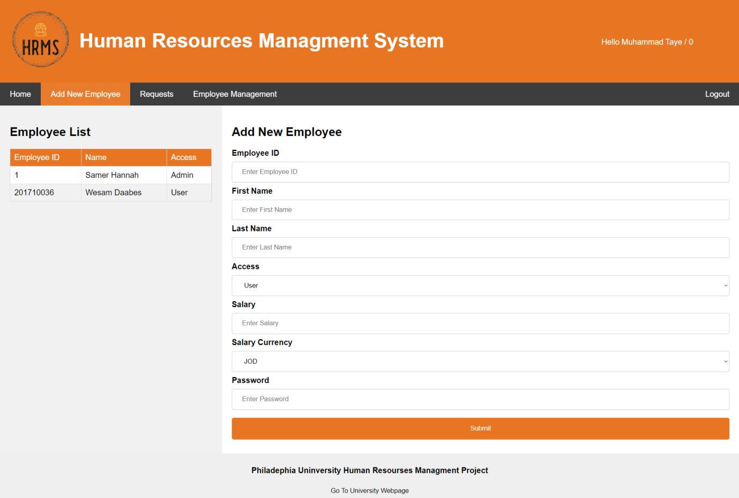

**Figure (22) Add new employee**

<?php

require 'conn.php';

$Employee_ID=$_POST['Employee_ID'];

$First_Name=$_POST['First_Name'];

$Last_Name=$_POST['Last_Name'];

$Access=$_POST['Access'];

$Employee_Salary=$_POST['Employee_Salary'];

$Employee_Salary_Currency=$_POST['Employee_Salary_Currency'];

$Password=$_POST['Password'];

$sql="INSERT INTO users (Employee_ID,First_Name,Last_Name,Access,Password,Employee_Salary,Employee_Salary_Currency) VALUES ('$Employee_ID','$First_Name','$Last_Name','$Access','$Password','$Employee_Salary','$Employee_Salary_Currency')";

$stmt = $conn->query($sql);

if($stmt) {

header('location: ../AddEmployee.php');

}

else

{

echo "Error";

}

?>

<?php

$fruits = array("d" => "lemon", "a" => "orange", "b" => "banana", "c" => "apple");

asort($fruits);

foreach ($fruits as $key => $val) {

echo "$key = $val\n";

}   
  
  
  
  
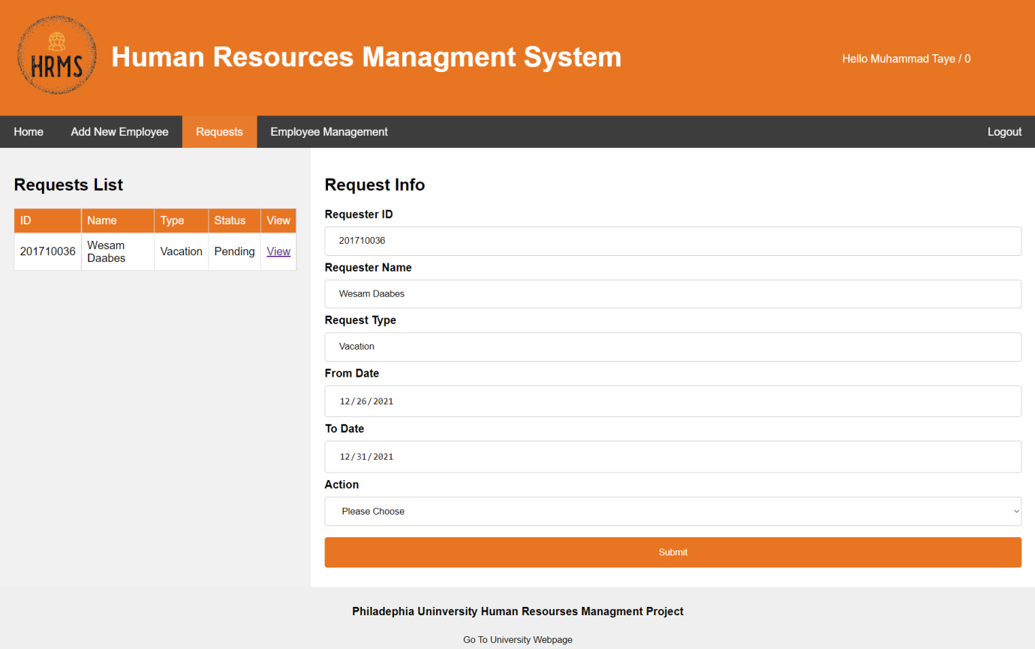

**Figure (23) Requests**

<?php

session_start();

if($_SESSION['Status']!="Active")

{

header('location:index.html');

exit;

}

?>

<?php

if($_SESSION['Access']=="Admin")

{

?>

<!DOCTYPE html>

<html lang="en">

<head>

<title>Requests</title>

<meta charset="UTF-8">

<meta name="viewport" content="width=device-width, initial-scale=1">

<div class="navbar">

<a href="Homepage.php">Home</a>

<?php

if ($_SESSION['Access']=="Admin") {

echo '<a href="AddEmployee.php">Add New Employee</a>';

}

?>

<?php

if ($_SESSION['Access']!="Admin") {

echo '<a href="MyRequests.php">My Requests</a>';

}

if ($_SESSION['Access']=="Admin") {

echo '<a href="Employee_Managment.php">Employee Management</a>';

}

if ($_SESSION['Access']!="Admin") {

echo '<a href="Employee_Managment.php">Edit My Info</a>';

}

?>

<a href="php/logout.php" class="right">Logout</a>

<h2>Requests List</h2>

<?php

require 'php/conn.php';

$Employee_ID=$_SESSION['Employee_ID'];

$sql="SELECT ID,Requester_ID,Requester_Name,Request_Type,Request_Status FROM requests WHERE Request_Status='Pending'";

$stmt = $conn->query($sql);

echo"<table>";

echo"<tr class='firstrow'><td>ID</td><td>Name</td><td>Type</td><td>Status</td><td>View</td></tr>";

while($row = $stmt->fetch_assoc()) {

$Requester_ID= $row['Requester_ID'];

$Requester_Name = $row['Requester_Name'];

$Request_Type= $row['Request_Type'];

$Request_Status=$row['Request_Status'];

$ROW_ID= $row['ID'];

echo"<tr><td>".$Requester_ID."</td><td>".$Requester_Name."</td><td>".$Request_Type."</td><td>".$Request_Status."</td><td><a href='http://localhost/HRMS/Requests.php?ID=".$Requester_ID."&Type=".$Request_Type."&ROW_ID=".$ROW_ID."'>View</a></td></tr>";

}

echo"</table>";

?>

<div class="footer">

<h4>Philadephia Uninversity Human Resourses Managment Project</h4>

<input class="WebpageButton" type="button" onclick="location.href='https://www.philadelphia.edu.jo';" value="Go To University Webpage" />

**Employee Portal :**

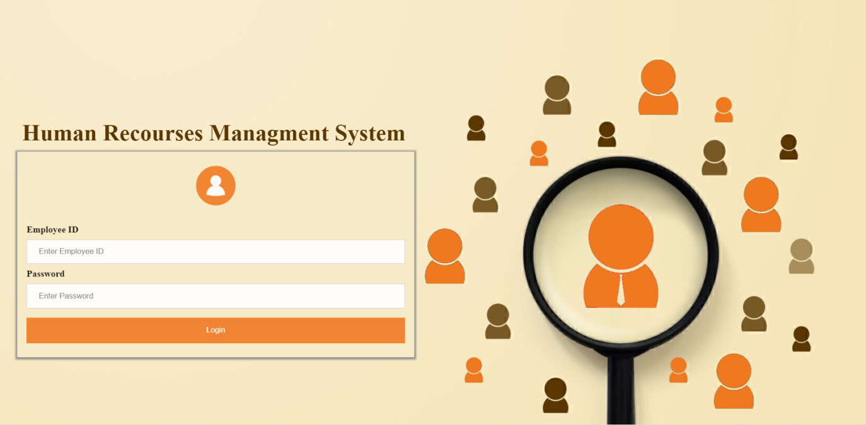

**Figure (24) Login**

<?php

session_start();

if (isset($_POST['Employee_ID']) && $_POST['Password'] != "") {

$Employee_ID=$_POST["Employee_ID"];

$Password=$_POST["Password"];

require 'conn.php';

$sql="SELECT * FROM users WHERE Employee_ID ='$Employee_ID' and Password='$Password'";

$stmt = $conn->query($sql);

while($row = $stmt->fetch_assoc()) {

$_SESSION['Employee_ID'] = $row['Employee_ID'];

$_SESSION['First_Name'] = $row['First_Name'];

$_SESSION['Last_Name'] = $row['Last_Name'];

$_SESSION['Access']= $row['Access'];

$_SESSION['Status']='Active';

header('location:../Homepage.php');

}

echo 'Wrong Username or Password !';

}

?>

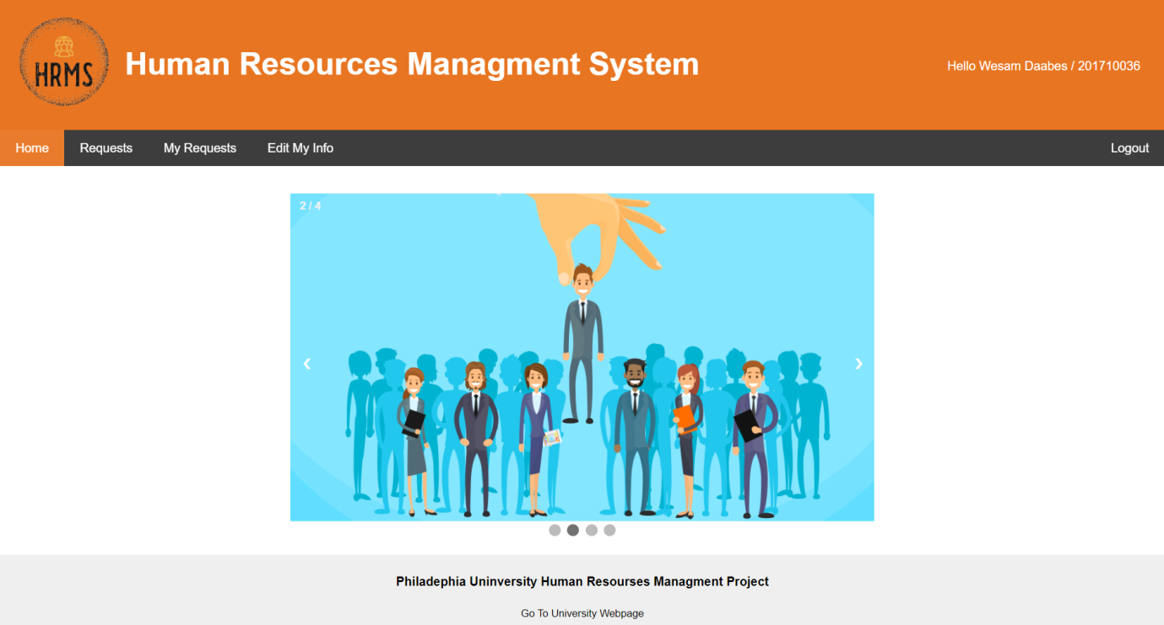

**Figure (25) Home page**

<?php

session_start();

if($_SESSION['Status']!="Active")

{

header('location:index.html');

exit;

}

?>

<!DOCTYPE html>

<html lang="en">

<head>

<title>HomePage</title>

<meta charset="UTF-8"

<meta name="viewport" content="width=device-width, initial-scale=1">

<style>

* {

<?php

if ($_SESSION['Access']=="Admin") {

echo '<a href="AddEmployee.php">Add New Employee</a>';

}

?>

<a href="Requests.php">Requests</a>

<?php

if ($_SESSION['Access']!="Admin") {

echo '<a href="MyRequests.php">My Requests</a>';

}

if ($_SESSION['Access']=="Admin") {

echo '<a href="Employee_Managment.php">Employee Management</a>';

}

if ($_SESSION['Access']!="Admin") {

echo '<a href="Employee_Managment.php">Edit My Info</a>';

}

?>

<a href="php/logout.php" class="right">Logout</a>

</div>

var slideIndex = 1;

showSlides(slideIndex);

function plusSlides(n) {

showSlides(slideIndex += n);

}

function currentSlide(n) {

showSlides(slideIndex = n);

}

function showSlides(n) {

var i;

var slides = document.getElementsByClassName("mySlides");

var dots = document.getElementsByClassName("dot");

if (n > slides.length) {slideIndex = 1}

if (n < 1) {slideIndex = slides.length}

for (i = 0; i < slides.length; i++) {

slides[i].style.display = "none";

}

for (i = 0; i < dots.length; i++) {

dots[i].className = dots[i].className.replace(" active", "");

}

slides[slideIndex-1].style.display = "block";

dots[slideIndex-1].className += " active";

}

</script>

<script>

let sliderimage=2;

setInterval(function() {

currentSlide(sliderimage);

sliderimage=sliderimage+1;

if(sliderimage>4){sliderimage=1;}

}, 2500);

</script>

<div class="footer">

<h4>Philadephia Uninversity Human Resourses Managment Project</h4>

<input class="WebpageButton" type="button" onclick="location.href='https://www.philadelphia.edu.jo';" value="Go To University Webpage" />

</div>

</body>

</html>

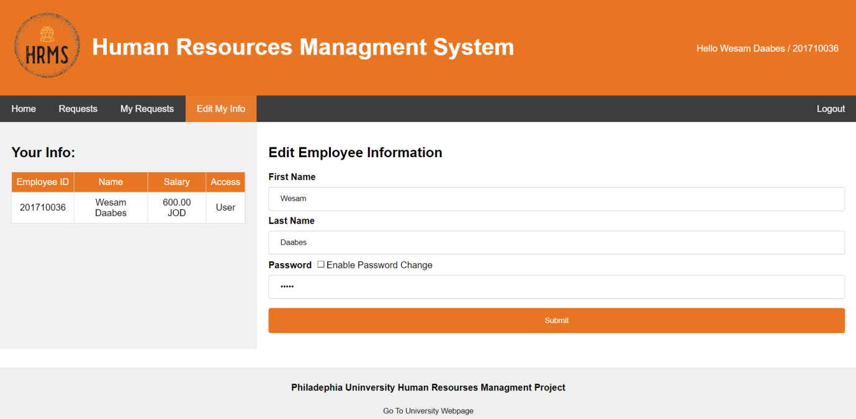

**Figure (26) Edit Employee information**

<?php

require 'conn.php';

session_start();

if($_SESSION['Access']=="Admin")

{

$UserRowID=$_POST['UserRowID'];

$Employee_ID=$_POST['Employee_ID'];

$First_Name=$_POST['First_Name'];

$Last_Name=$_POST['Last_Name'];

$Access=$_POST['Access'];

$Employee_Salary=$_POST['Employee_Salary'];

$Employee_Salary_Currency=$_POST['Employee_Salary_Currency'];

$Password=$_POST['Password'];

$sql="UPDATE users SET Employee_ID='$Employee_ID',

First_Name='$First_Name',

Last_Name='$Last_Name',

Access='$Access',

Password='$Password',

Employee_Salary='$Employee_Salary',

Employee_Salary_Currency='$Employee_Salary_Currency' WHERE ID='$UserRowID'";

$stmt = $conn->query($sql);

if($stmt) {

header('location: ../Employee_Managment.php?Message=User Updated Successfully !!!');

}

else

{

echo "Error";

}

}

else if($_SESSION['Access']=="User")

{

$UserRowID=$_POST['UserRowID'];

$First_Name=$_POST['First_Name'];

$Last_Name=$_POST['Last_Name'];

$Password=$_POST['Password'];

$sql="UPDATE users SET First_Name='$First_Name',

Last_Name='$Last_Name',

Password='$Password' WHERE ID='$UserRowID'";

$stmt = $conn->query($sql);

if($stmt) {

header('location: ../Employee_Managment.php?Message=User Updated Successfully !!!');

}

else

{

echo "Error";

}

}

?>

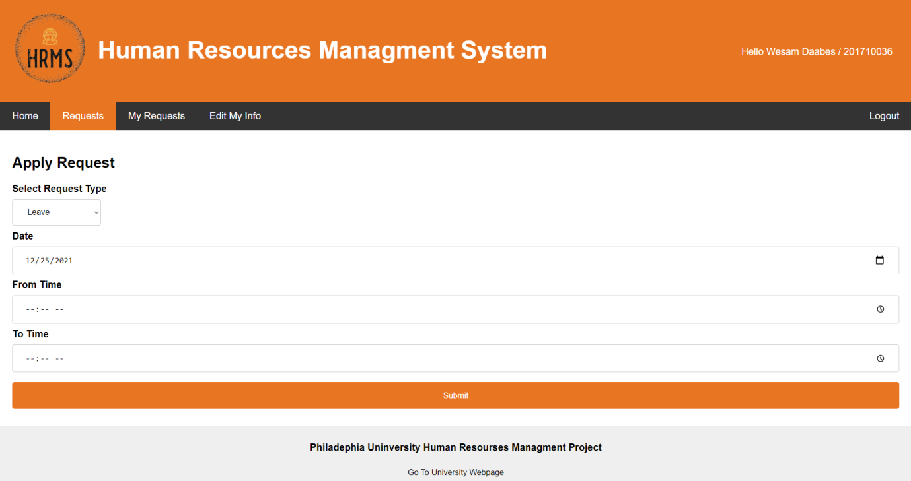

**Figure (27) Requests**

<?php

session_start();

if($_SESSION['Status']!="Active")

{

header('location:index.html');

exit;

}

?>

<?php

if($_SESSION['Access']=="Admin")

{

?>

<!DOCTYPE html>

<html lang="en">

<head>

<title>Requests</title>

<meta charset="UTF-8">

<meta name="viewport" content="width=device-width, initial-scale=1">

<div class="navbar">

<a href="Homepage.php">Home</a>

<?php

if ($_SESSION['Access']=="Admin") {

echo '<a href="AddEmployee.php">Add New Employee</a>';

}

?>

<?php

if ($_SESSION['Access']!="Admin") {

echo '<a href="MyRequests.php">My Requests</a>';

}

if ($_SESSION['Access']=="Admin") {

echo '<a href="Employee_Managment.php">Employee Management</a>';

}

if ($_SESSION['Access']!="Admin") {

echo '<a href="Employee_Managment.php">Edit My Info</a>';

}

?>

<a href="php/logout.php" class="right">Logout</a>

<h2>Requests List</h2>

<?php

require 'php/conn.php';

$Employee_ID=$_SESSION['Employee_ID'];

$sql="SELECT ID,Requester_ID,Requester_Name,Request_Type,Request_Status FROM requests WHERE Request_Status='Pending'";

$stmt = $conn->query($sql);

echo"<table>";

echo"<tr class='firstrow'><td>ID</td><td>Name</td><td>Type</td><td>Status</td><td>View</td></tr>";

while($row = $stmt->fetch_assoc()) {

$Requester_ID= $row['Requester_ID'];

$Requester_Name = $row['Requester_Name'];

$Request_Type= $row['Request_Type'];

$Request_Status=$row['Request_Status'];

$ROW_ID= $row['ID'];

echo"<tr><td>".$Requester_ID."</td><td>".$Requester_Name."</td><td>".$Request_Type."</td><td>".$Request_Status."</td><td><a href='http://localhost/HRMS/Requests.php?ID=".$Requester_ID."&Type=".$Request_Type."&ROW_ID=".$ROW_ID."'>View</a></td></tr>";

}

echo"</table>";

?>

<div class="footer">

<h4>Philadephia Uninversity Human Resourses Managment Project</h4>

<input class="WebpageButton" type="button" onclick="location.href='https://www.philadelphia.edu.jo';" value="Go To University Webpage" />

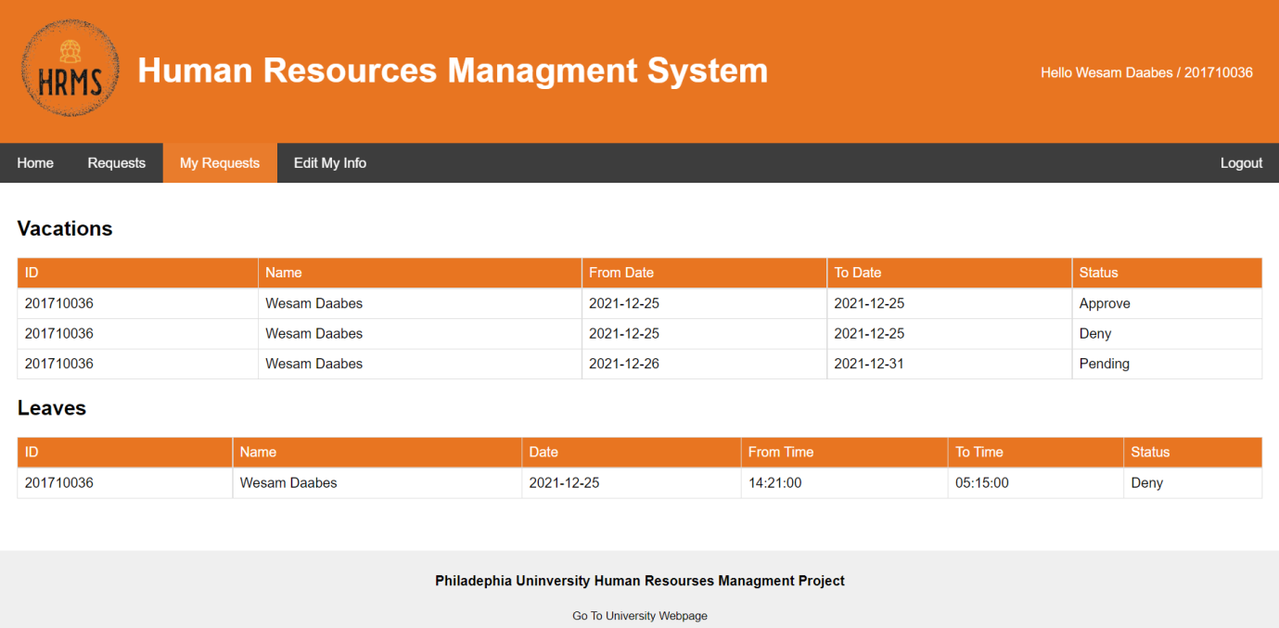

**Figure (28) My requests**

<?php

session_start();

if($_SESSION['Status']!="Active")

{

header('location:index.html');

exit;

}

?>

<!DOCTYPE html>

<html lang="en">

<head>

<title>Requests</title>

<meta charset="UTF-8">

<meta name="viewport" content="width=device-width, initial-scale=1">

<div class="header">

<img src="images/logo.png" style="height: auto;position: absolute;margin-left: -58%;width: 27%;margin-top: -3%;" class="left" ><h1 style="margin-left:-30%;margin-top:2.7%;">Human Resources Managment System</h1><h1 style="color:transparent;margin-top:-4%;margin-left:150%;overflow:hidden;">.</h1>

<p style="margin-left:80%;margin-top:-4.8%;position:absolute;"><?php echo "Hello " . $_SESSION['First_Name'] . " " . $_SESSION['Last_Name'] . " / " . $_SESSION['Employee_ID'] ; ?></p>

</div>

<div class="navbar">

<a href="Homepage.php">Home</a>

<?php

if ($_SESSION['Access']=="Admin") {

echo '<a href="AddEmployee.php">Add New Employee</a>';

}

?>

<a href="Requests.php">Requests</a>

<?php

if ($_SESSION['Access']!="Admin") {

echo '<a style="background-color:#E87521;" href="MyRequests.php">My Requests</a>';

}

if ($_SESSION['Access']=="Admin") {

echo '<a href="Employee_Managment.php">Employee Management</a>';

}

if ($_SESSION['Access']!="Admin") {

echo '<a href="Employee_Managment.php">Edit My Info</a>';

}

?>

<a href="php/logout.php" class="right">Logout</a>

<?php

require 'php/conn.php';

$Employee_ID=$_SESSION['Employee_ID'];

$sql="SELECT * FROM requests WHERE Requester_ID='$Employee_ID' AND Request_Type='Vacation'";

$stmt = $conn->query($sql);

echo"<table>";

echo"<tr class='firstrow'><td>ID</td><td>Name</td><td>From Date</td><td>To Date</td><td>Status</td></tr>";

while($row = $stmt->fetch_assoc()) {

$Requester_ID= $row['Requester_ID'];

$Requester_Name = $row['Requester_Name'];

$Request_Status=$row['Request_Status'];

$From_Date=$row['From_Date'];

$To_Date=$row['To_Date'];

$ROW_ID= $row['ID'];

echo"<tr><td>".$Requester_ID."</td><td>".$Requester_Name."</td><td>".$From_Date."</td><td>".$To_Date."</td><td>".$Request_Status."</td></tr>";

}

echo"</table>";

?>

<h2>Leaves</h2>

<?php

$sql1="SELECT * FROM requests WHERE Requester_ID='$Employee_ID' AND Request_Type='Leave'";

$stmt1 = $conn->query($sql1);

echo"<table>";

echo"<tr class='firstrow'><td>ID</td><td>Name</td><td>Date</td><td>From Time</td><td>To Time</td><td>Status</td></tr>";

while($row1 = $stmt1->fetch_assoc()) {

$Requester_ID= $row1['Requester_ID'];

$Requester_Name = $row1['Requester_Name'];

$Request_Status=$row1['Request_Status'];

$From_Date=$row1['From_Date'];

$From_Time=$row1['From_Time'];

$To_Time=$row1['To_Time'];

$ROW_ID= $row1['ID'];

echo"<tr><td>".$Requester_ID."</td><td>".$Requester_Name."</td><td>".$From_Date."</td><td>".$From_Time."</td><td>".$To_Time."</td><td>".$Request_Status."</td></tr>";

}

echo"</table>";

?>

</div>

<div class="footer">

<h4>Philadephia Uninversity Human Resourses Managment Project</h4>

<input class="WebpageButton" type="button" onclick="location.href='https://www.philadelphia.edu.jo';" value="Go To University Webpage" />

</div>

</body>

</html>

**Chapter 6 – Testing**

**Overview**

The purpose of this chapter is to show the results of the testing phase and verifications applied to the Human resources management system.

A number of testing methods were chosen to insure that the system works correctly and is matching the requirements specified earlier.

**Black box testing.  
Table 7: Black box testing :**

|  |  |  |  |  |
| --- | --- | --- | --- | --- |
| Result | Expected Output | Actual Input | Test case | Test case number |
| pass | Login succeeds and home page presented | Employee id : 201710036 password : 12345 | Testing Login | 1 |
| pass | Wrong username or password! | Employee id : 201720043 password : 12335 | Testing Login | 2 |
| pass | Login succeeds and home page presented | Employee id : 0 password : 12345 | Testing login by admin | 3 |
| pass | Wrong username or password! | Employee id : 0213 password : 12345 | Testing login by admin | 4 |
| pass | Employee is added | Valid employee data | Add new employee by  admin | 5 |
| pass | Request is added | Valid request data | Add requests for employee by admin | 6 |
| Pass | Employee is editing | Pressing submit button | Editing employee information by admin | 7 |
| pass | Employee is editing | Pressing submit button | Edit personal employee information | 8 |
| Pass | Status leave accepted | Enter valid Id and name and date | Approve a leave or vacation employee by admin | 9 |
| Pass | status leave rejected | Enter valid Id and name and date | Deny a leave or vacation of employee by admin | 10 |
| Pass | Password is changed | Enter valid new password | Change password by admin | 11 |
| pass | Request is applied | Enter request type and date | Apply request by admin | 12 |

Cases of errors during testing:   
  
1- log in using invalid employee number and password

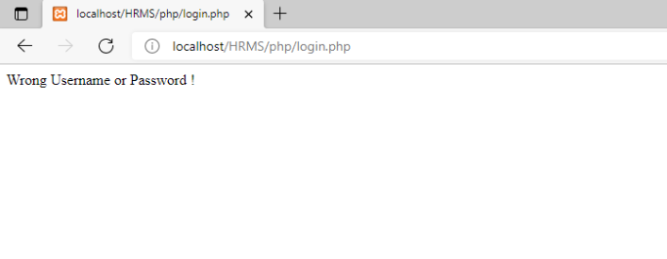  
 Figure(29):

When the employee enters invalid number or password this page will appear to him. .  
2- Editing employee information by a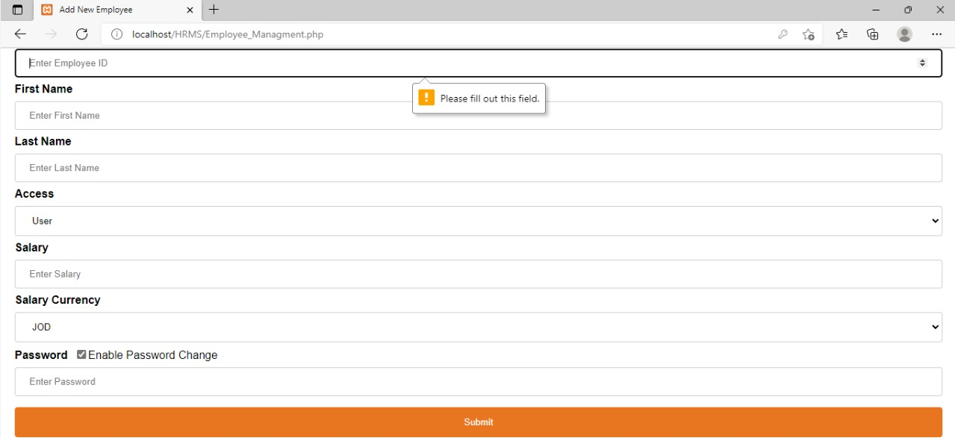  
 Figure(30):

when the admin did not enter any information in this page .  
3- Edit personal employee information   
  
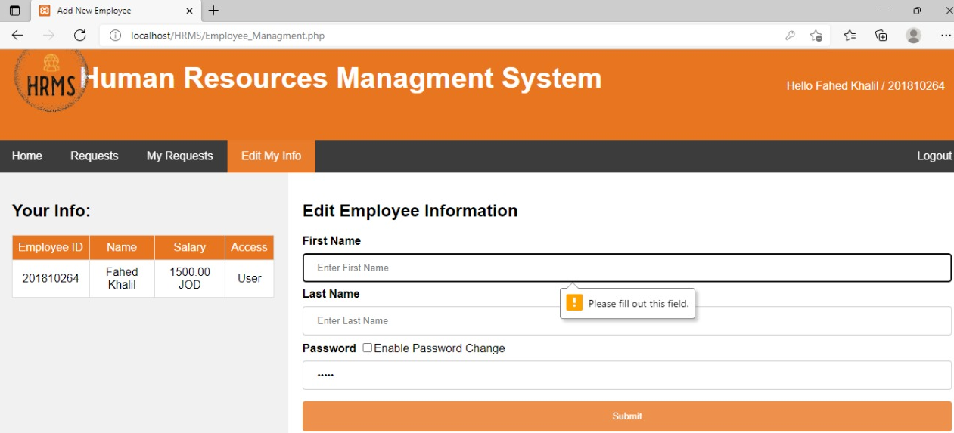  
 Figure(31):

when the employee did not enter first name a message box will app

4- Add requests for employee by admin   
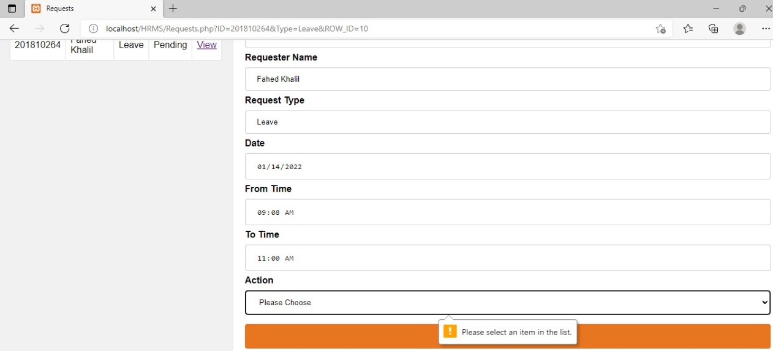  
 Figure(32):

when the admin fill all the fields except the field of action a message box will appear to him

5- add new employee by admin   
  
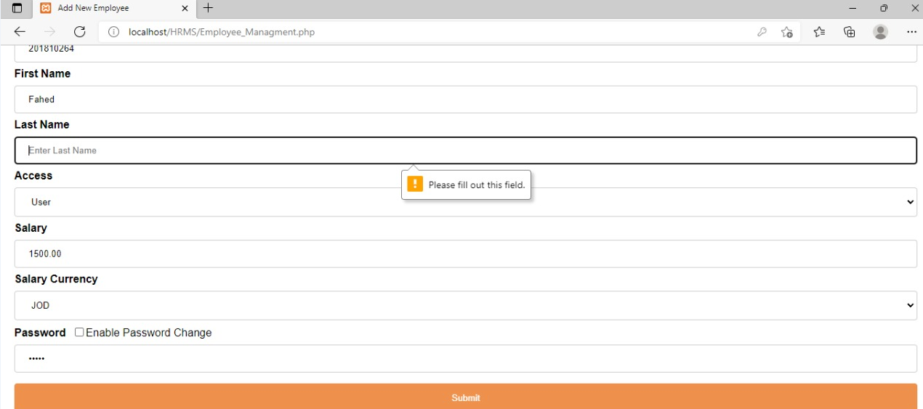  
 Figure(33):

when the admin enter all information about the employee but did not fill the field of last name a message box will appear to him.

**Testing by using**   
**Table 8 : Testing by using**

|  |  |  |
| --- | --- | --- |
| Answer | Question | Number of question |
| Yes | Does it really work as expected? | 1 |
| Yes | Does it meet the user's requirements? | 2 |
| Yes | Is it what the users expect? | 3 |
| Yes | Do the users like it? | 4 |
| No | Is it compatible with our other systems? | 5 |
| It passes all tests | How well does it work? | 6 |
| it is meeting the requirements  specification | What does it mean to you that “it works”? | 7 |
| if large number of users used it  at the same time | What might cause it to not to work well? | 8 |

**Chapter 7 - Conclusion and future work**

**Conclusion:**

After reviewing the current study and studying it thoroughly ,The Human Resource Management System is an effective system that could be applied and used in many companies . Accordioning to that the system was analyzed and work on establishing a system that manages human resources according to the foundation of any company.

By the website.1) Manager is able to rely on him to manage and control employee data, as well as to manage attendance and absence records.2) Manager also can manage the records of vacations and financial matters for all employees easily.3) By using the website, the administrator can extract reports by employees and all related information.4) Employee can manage his data easily.

**Future work:**

1. Develop more sections needed by human resources such as performance assessment and vocational training.
2. Analysis of the consequences of the system.
3. Develop the website and improve its performance by studying the conversion to Android and ios application, while the website remains.

**References**

**IEEE Citation Style Guide**

**World Wide Web**

A.projects*. “Title.” Web student portal for the it and management: www.freeprojectz.com, Nov.7,2014* [March.10,3,2021].

**Lecture**

M. Tayee. Dr. final project, Topic: “discussing.” ICT 224, Faculty of IT, University of Philadelphia, Jordan, Amman, April. 31, 2021.

**E-mail**

W.daabes “new message ,done?wesamdaabes98@gmail.com ”. (April.3,2021).

**Appendix**

1. **Supervisor:** Dr. Mohammad Taye
2. **Project Title:** HR management system
3. **Goals and Objectives**

1) Useability and efficiency of employees services.

2) Generate reports of employee leaves or vacation and complaints.

3) To Add the employee salary.

1. **Brief description of the project**

The proposed project "HR Management System" has been developed to overcome the problems faced in the practicing of manual system. This software is built to eliminate and in some cases reduce the hardships faced by the existing system. Moreover this system is designed for particular need of the company to carry out its operations in a smooth and effective manner.

It is a special system for employees in any company in which basic jobs are available for any

employee, such as (vacations - leaves – edit info - monthly salary ).

1. **References** **:1)**

**IEEE Citation Style Guide**

**World Wide Web**

A.projects*. “Title.” Web student portal for the it and management : www.freeprojectz.com, Nov.7,2014* [March.10,3,2021].

**Lecture**

M. Tayee. Dr. final project, Topic: “discussing.” ICT 224, Faculty of IT, University of Philadelphia, Jordan, Amman, April. 31, 2021.

**E-mail**

W.daabes “new message ,done?wesamdaabes98@gmail.com ”. (April.3,2021).

1. **Project Requirements (Hardware & Software)**

.**-**

1. **Company** **or organization (If applicable)**   
   not applicable
2. **Prerequisite**   
    Completion of 90 study hours
3. **Project Specialization (Software Engineering)**Software Engineering
4. **Fahed Khalil Color is (Black)**
5. **Malik Qawasmeh Color is (Blue)**
6. **Wesam Da abes Color is (Red)**

Supervisor Signature Date

Note: This is completed by the supervisor, and submitted to the Graduation Project Committee